SEMESTER ONE
Papers written by
Australian Maths Software

YEAR 12

MATHEMATICS SPECIALIST
REVISION 3
UNIT 3

2016

Section One
(Calculator–free)

Name: _________________________________

Teacher: ________________________________

TIME ALLOWED FOR THIS SECTION

Reading time before commencing work: 5 minutes
Working time for section: 50 minutes

MATERIAL REQUIRED / RECOMMENDED FOR THIS SECTION

To be provided by the candidate
Standard items: pens, pencils, pencil sharpener, highlighter, eraser, ruler.
Special items: nil.

IMPORTANT NOTE TO CANDIDATES
No other items may be taken into the examination room. It is your responsibility to ensure that you do not have any unauthorised notes or other items of a non–personal nature in the examination room. If you have any unauthorised material with you, hand it to the supervisor before reading any further.

To be provided by the supervisor
Question/answer booklet for Section One.
A formula sheet which may also be used for Section Two.
Structure of this examination

 | Number of questions available | Number of questions to be answered | Working time (minutes) | Marks available | Percentage of exam
Section One  Calculator—free | 5 | 5 | 50 | 50 | 35
Section Two  Calculator—assumed | 12 | 12 | 100 | 100 | 65
Total marks |  |  |  | 150 | 100

Instructions to candidates

1. The rules for the conduct of this examination are detailed in the Information Handbook.
Sitting this examination implies that you agree to abide by these rules.

2. Write your answer in the Question/Answer booklet.

3. You must be careful to confine your responses to the specific questions asked and to
follow any instructions that are specific to a particular question.

4. Spare pages are provided at the end of this booklet. If you need to use them, indicate
in the original answer space where the answer is continued i.e. give the page number.

5. Show all your working clearly. Your working should be in sufficient detail to allow your
answers to be checked readily and for marks to be awarded for reasoning. Incorrect
answers given without supporting reasoning cannot be allocated any marks. For any
question or part question worth more than two marks, valid working or justification is
required to receive full marks. If you repeat an answer to any question, ensure that you
cancel the answer you do not wish to have marked.

6. It is recommended that you do not use pencil, except in diagrams.

7. The Formula Sheet is not to be handed in with your Question/Answer booklet.

1. (6 marks)
(a) The graph of is drawn for  on the set of axes below.
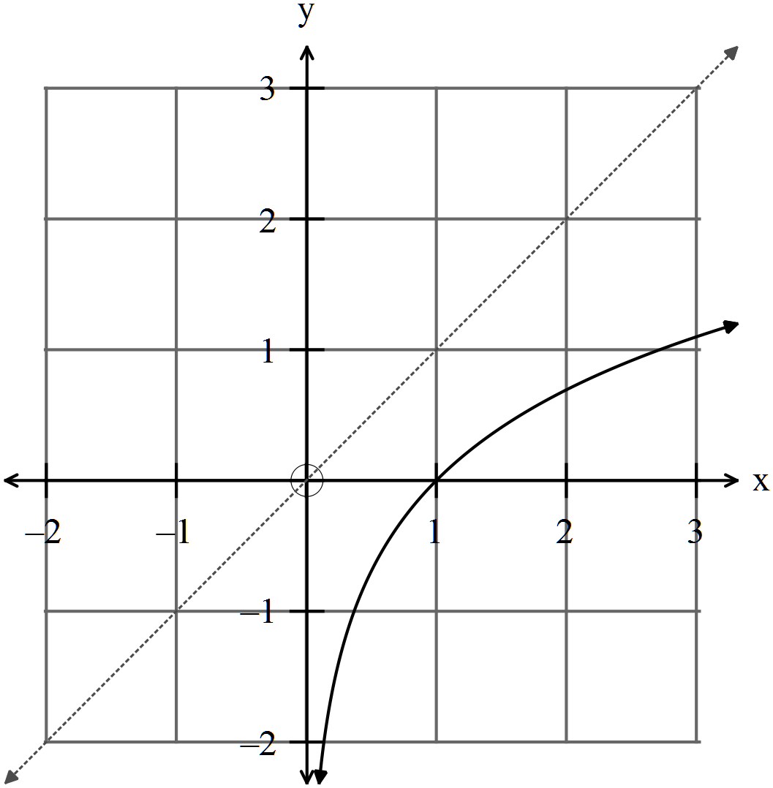

(i) Sketch the inverse function 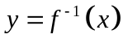. (1)

(ii) Write down the equation of both functions, and . (2)

(iii) Write down the domain and the range of . (2)

(iv) Given 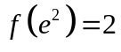, find 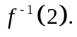 (1)

2. (10 marks)

Matrices can be used to solve systems of equations such as

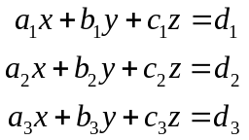

where each equation represents a plane in space.

Solve each the following where possible and interpret the result.

(a) 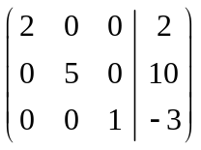 (1)

(b) 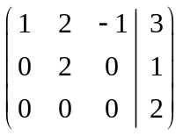 (2)

(c) 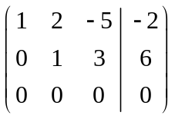 (2)

(d) 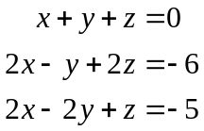 (5)

3. (8 marks)
(a) Given the sketch of the function 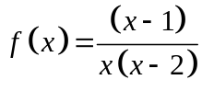
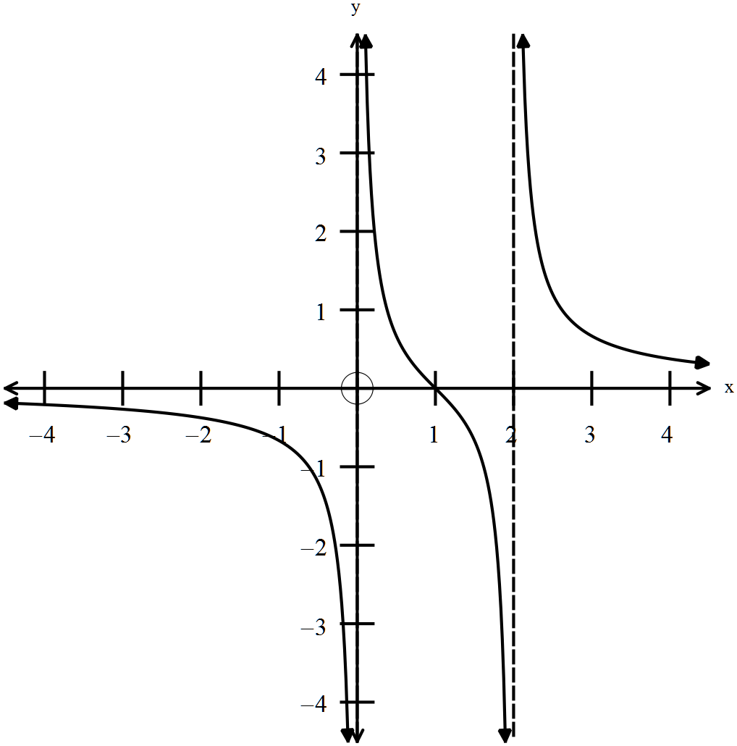
find the equations of the graphs below.

(i) (1)
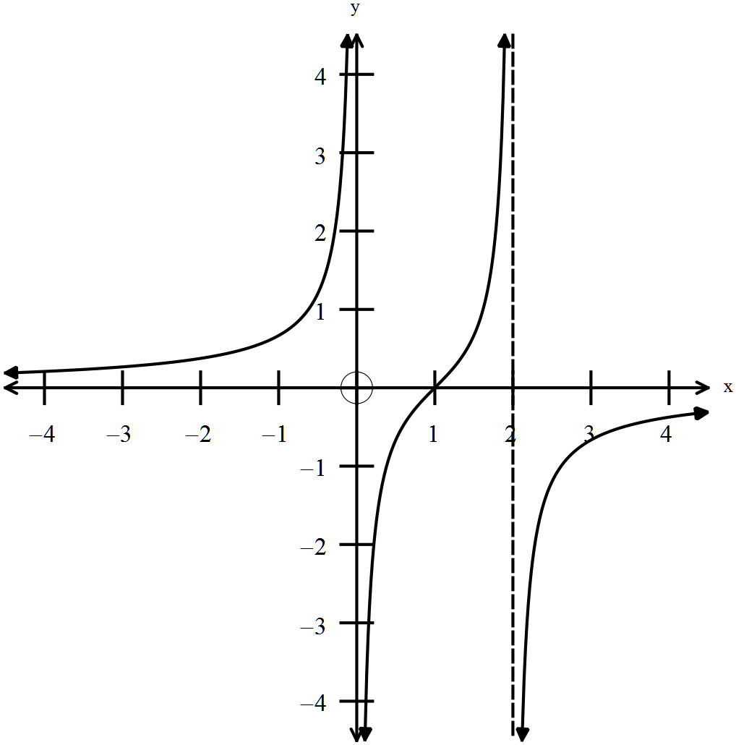
(ii) (3)
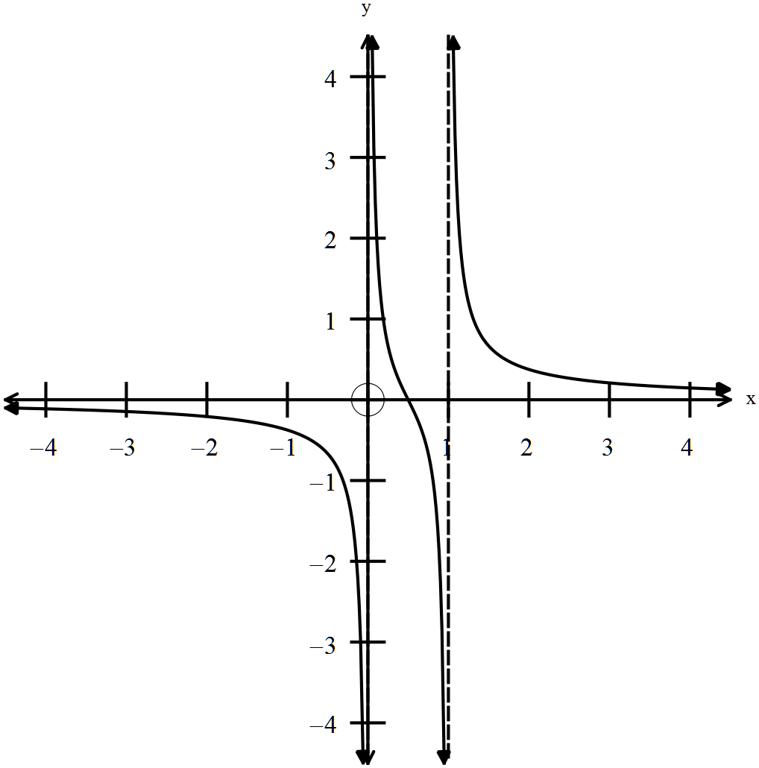
(iii) (4)
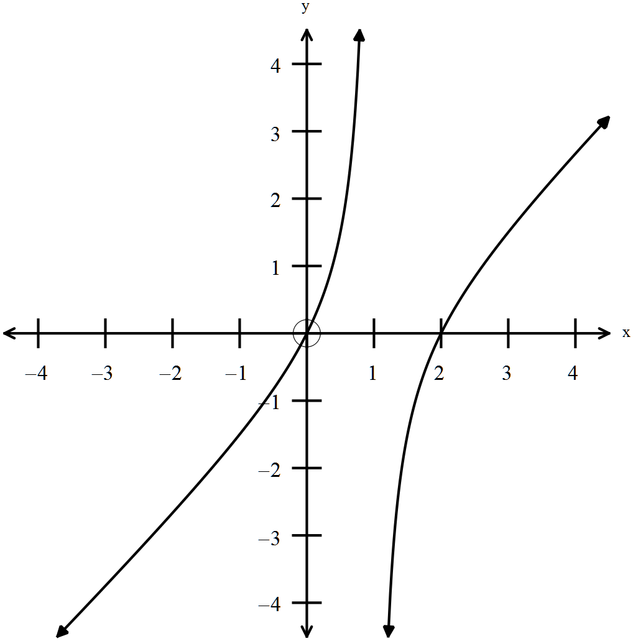

4. (13 marks)

(a) Given 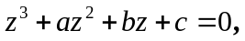 find the values of 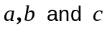 if the roots of the equation are 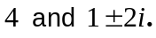 (3)

(b) Given one solution to the equation 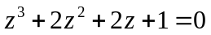 is 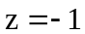, find the other
two solutions. (4)

(c) (i) Determine the solutions of the equation 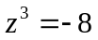 for 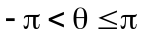. (3)

(ii) Explain the relationship between the roots. (1)

(iii) Illustrate the roots on the diagram below. (2)

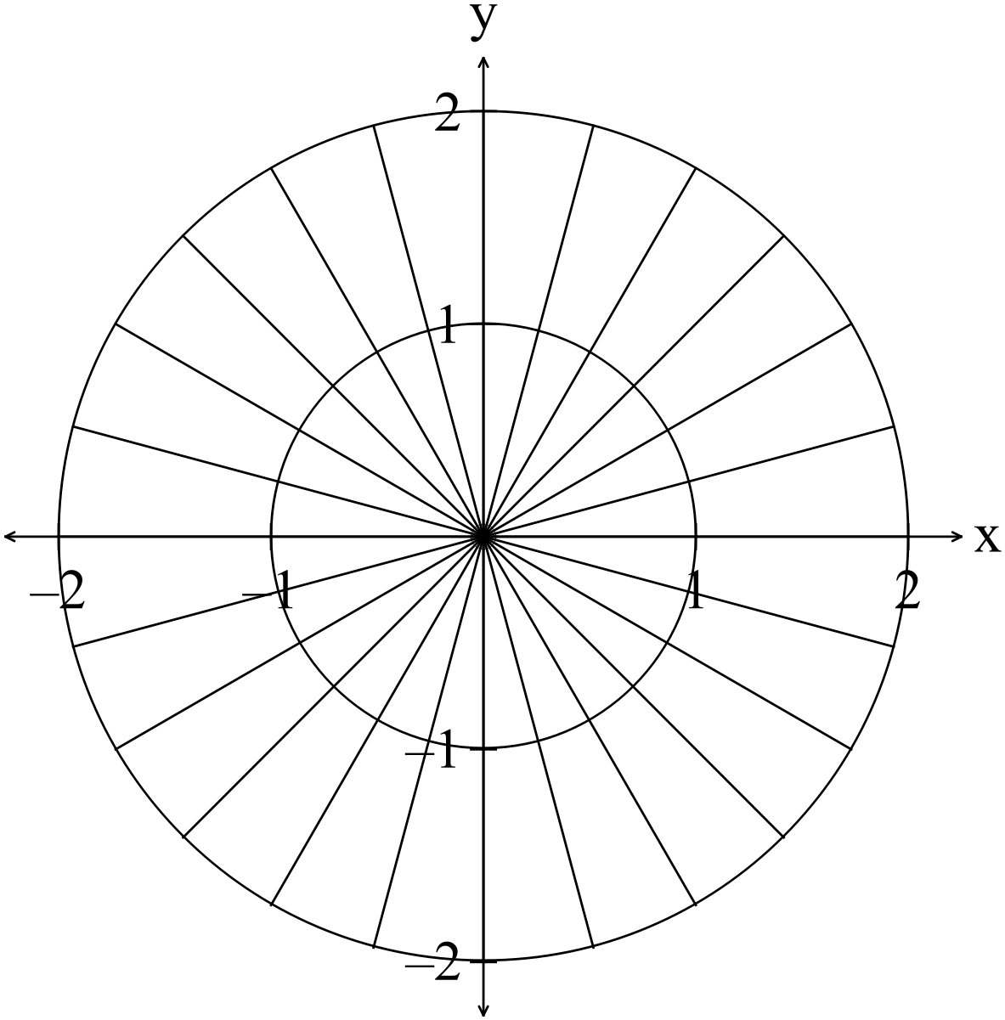
5. (13 marks)

(a) Simplify 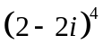 (1)

(b) Express 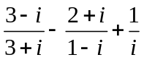 with a rational denominator (3)

(c) Find real numbers 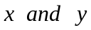 such that 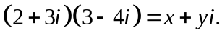. (2)

(d) Sketch 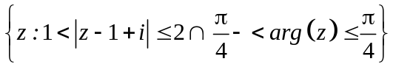 on the set of axes below. (2)

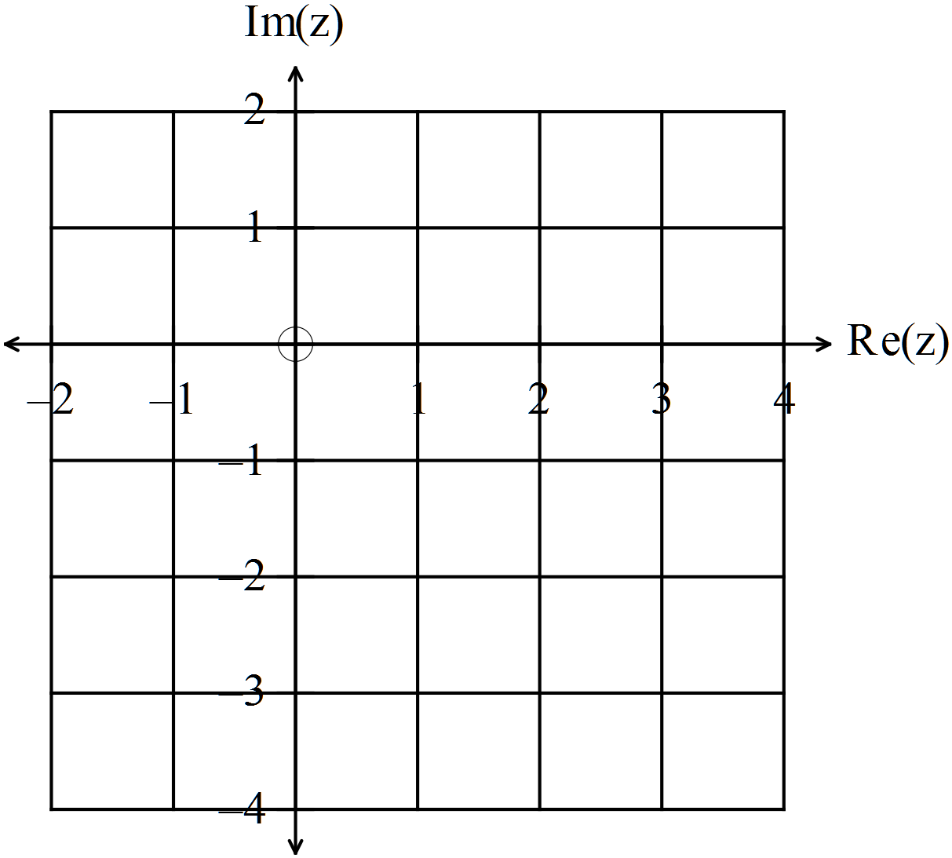

(e) Sketch 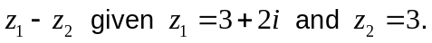 on the set of axes below. (2)
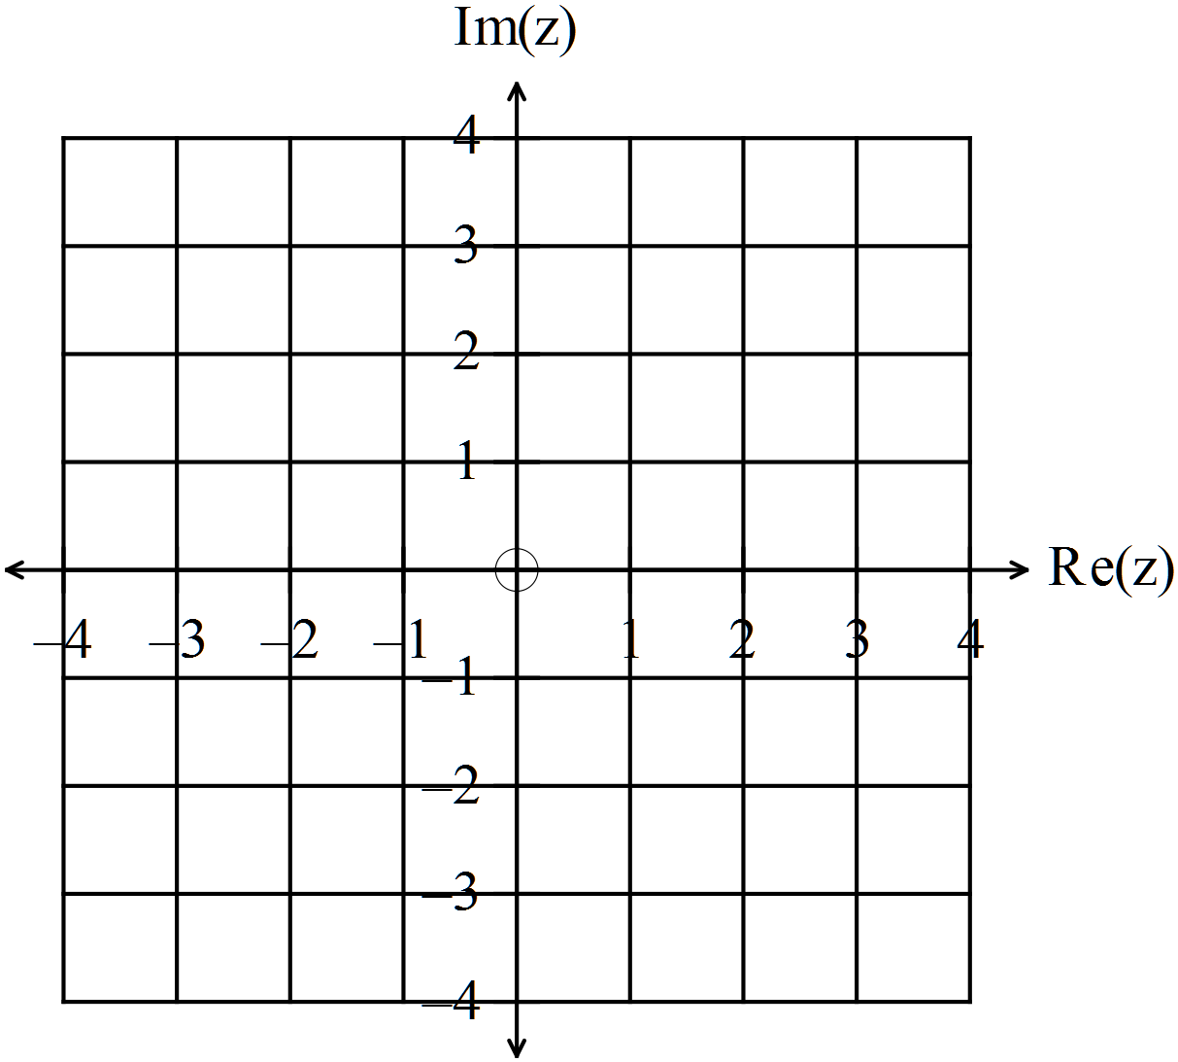
(f) If 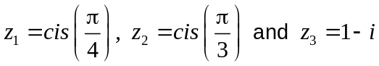
evaluate 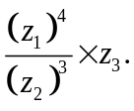 (3)

END OF SECTION ONE

